WonBin Seo
Dr. Shannon Nicley,
ECE 813 Advanced VLSI Design
19 February 2025
Exam1
Problem 1 – NOR2 Schematic
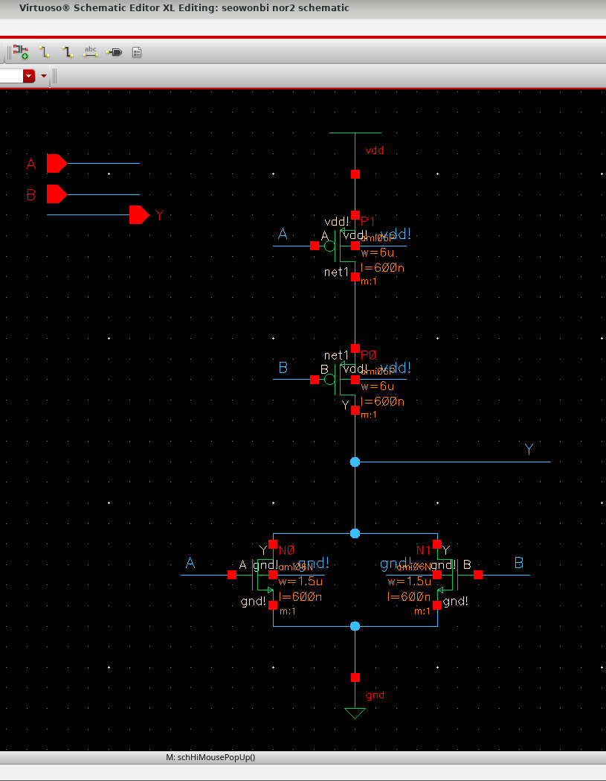

Problem 2 – NOR2 Symbol
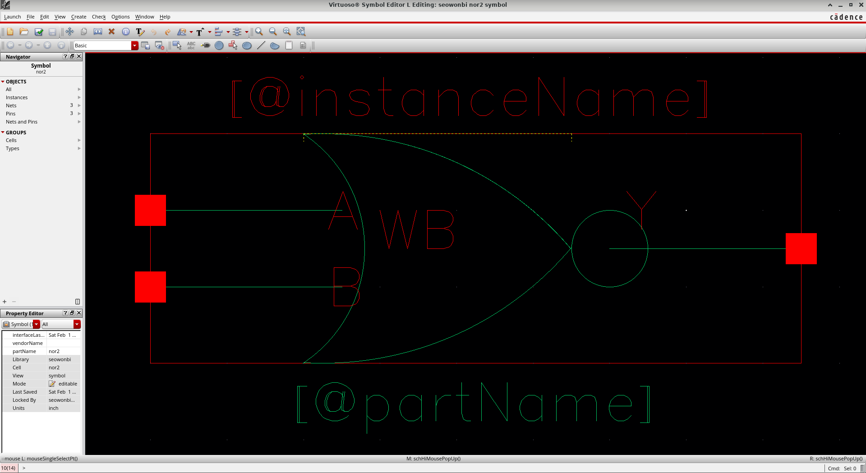

Problem 3 – NOR2 Simulation
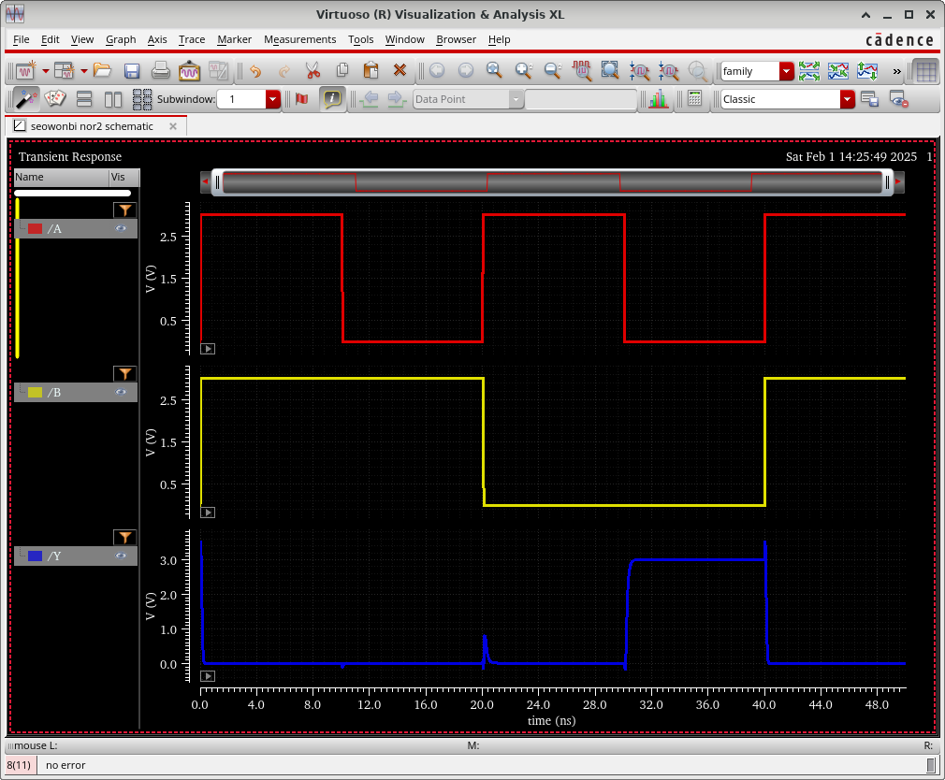
Problem 3 – NOR2 Stimulus File
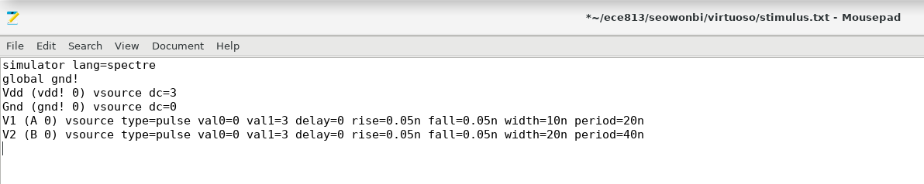

Problem 4 – NOR2 Layout
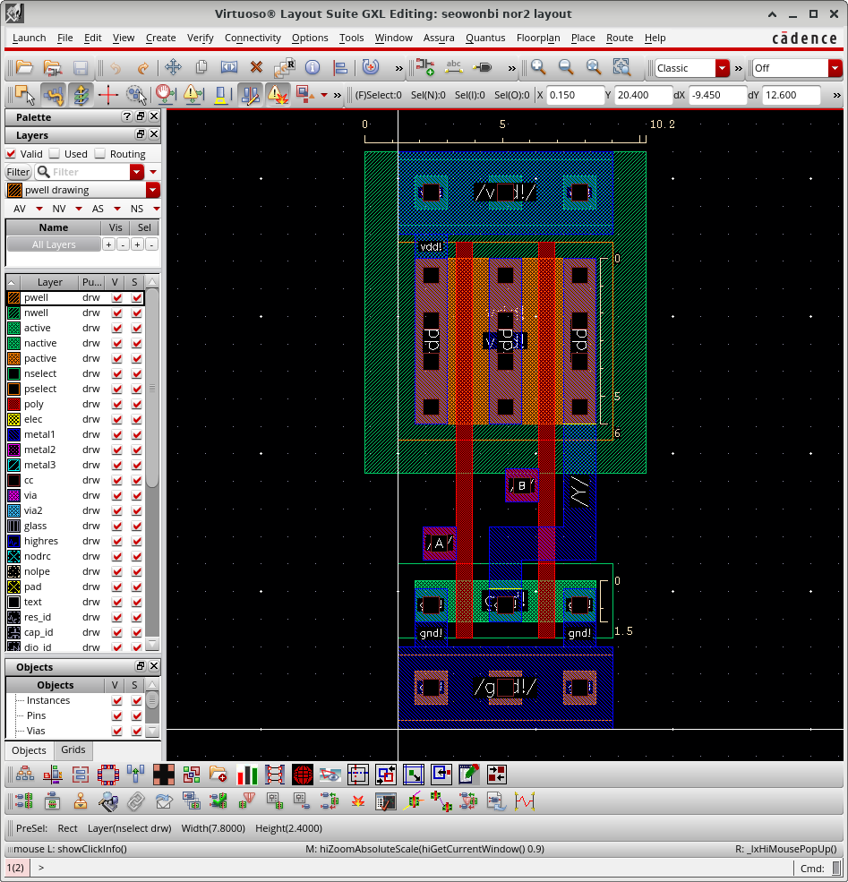
Problem 5 – NOR2 LVS
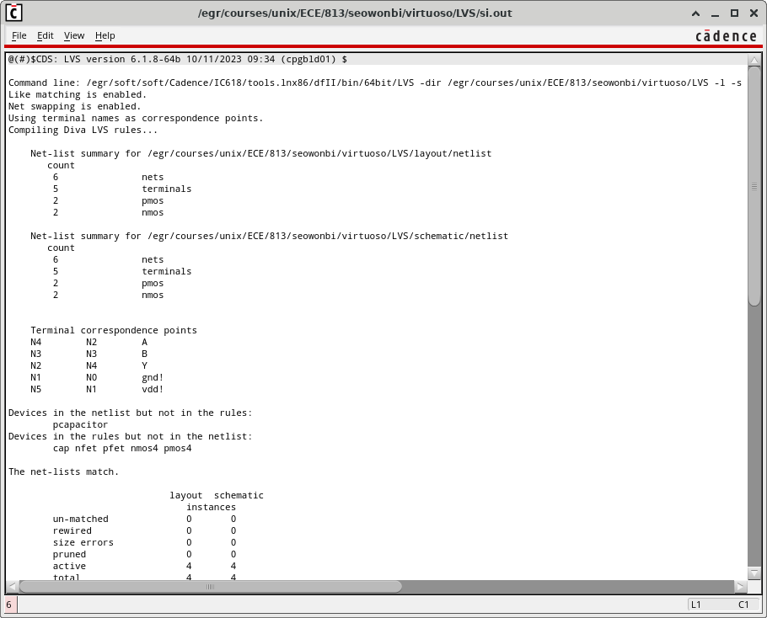

Problem 6 – MUX21 Schematic
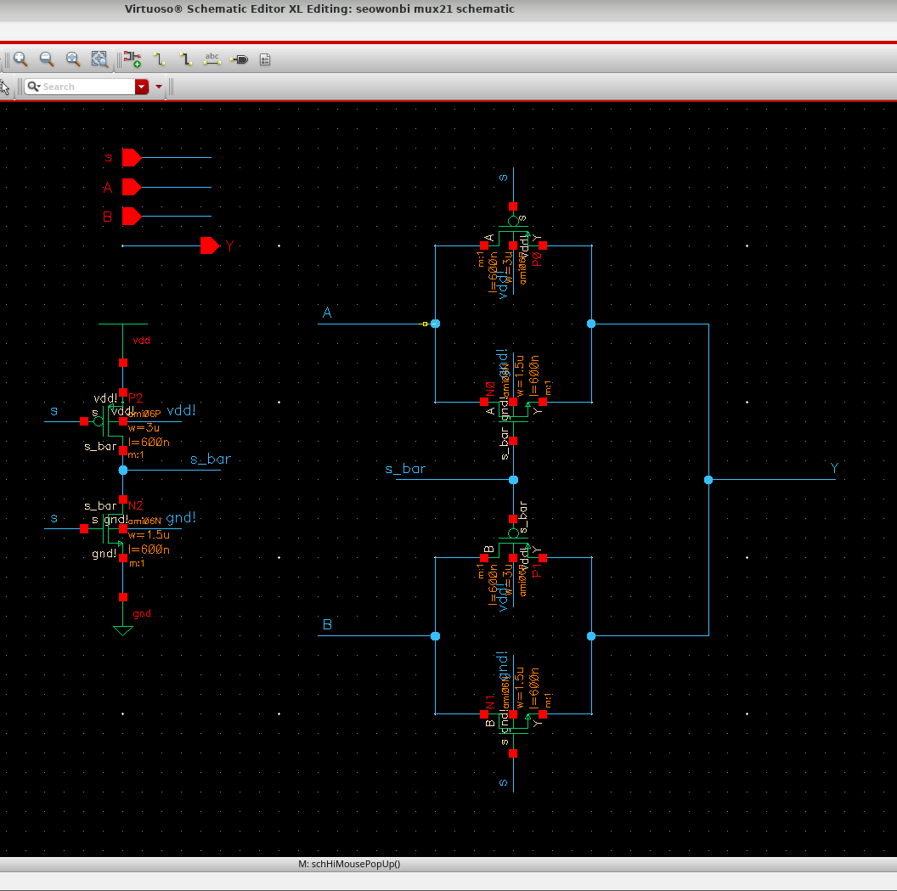

Problem 7 – MUX21 Symbol
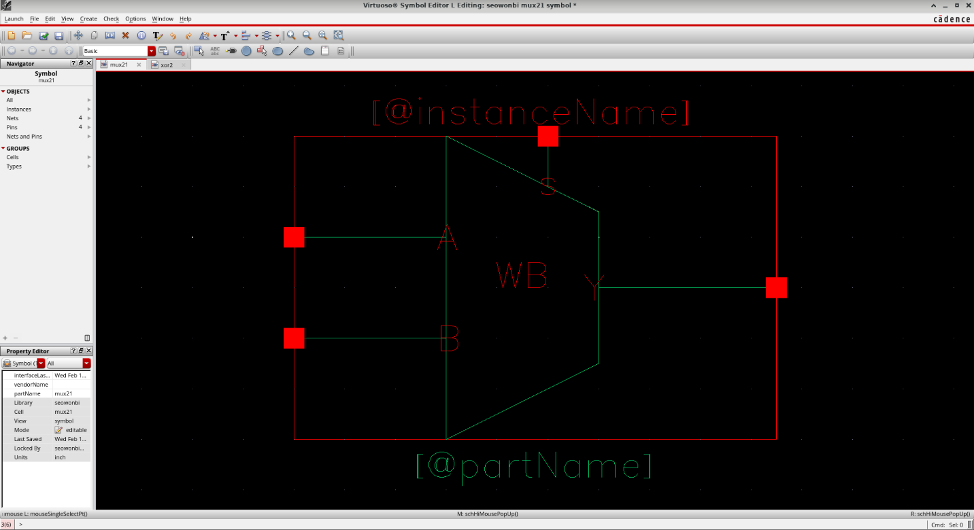

Problem 8 – MUX21 Simulation
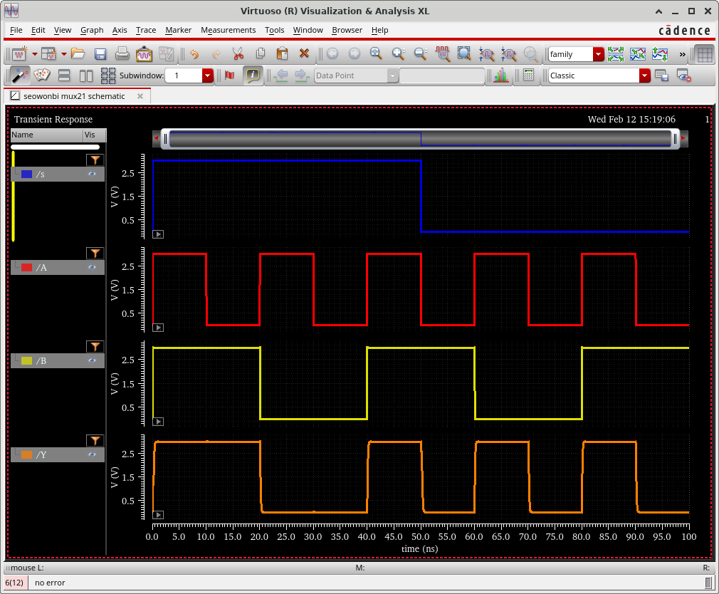
Problem 8 – MUX21 Stimulus File
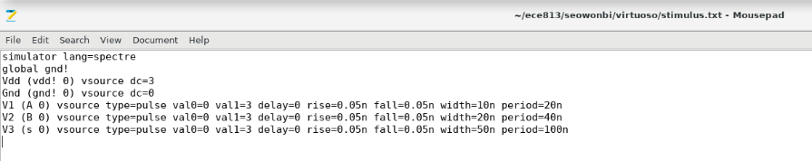

Problem 9 – MUX21 Layout
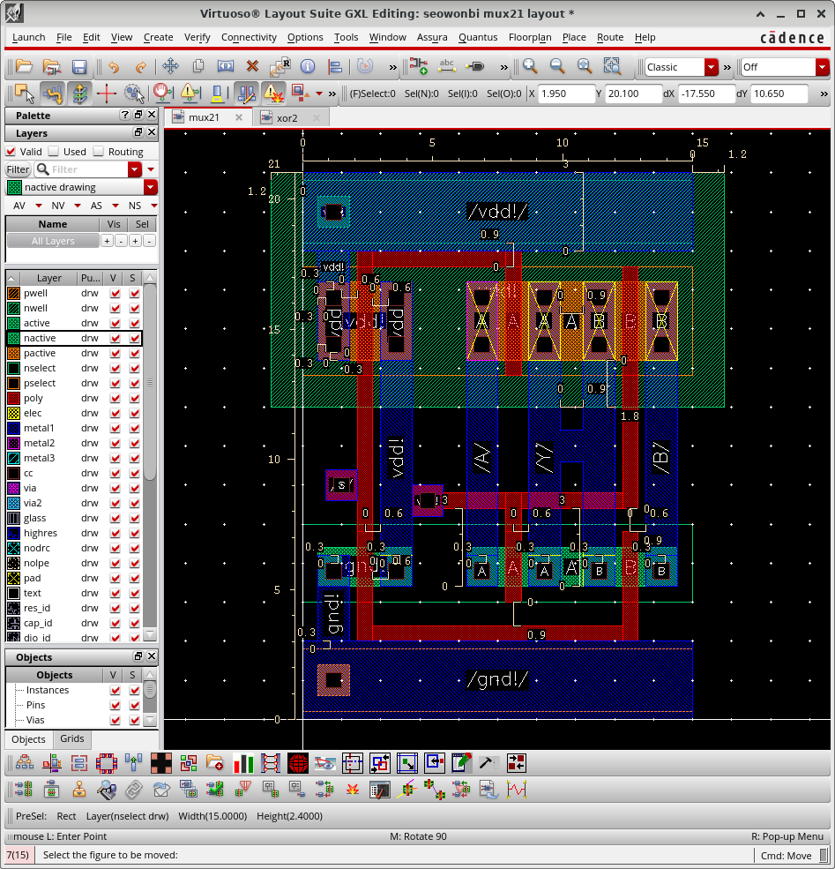
Problem 10 – MUX21 LVS
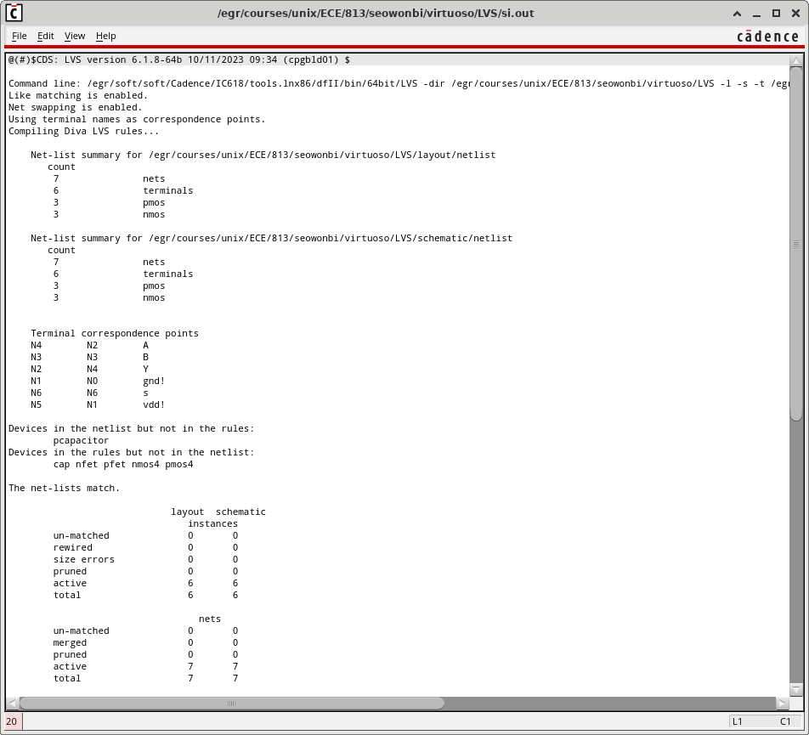

Problem 11 – XOR2 Layout
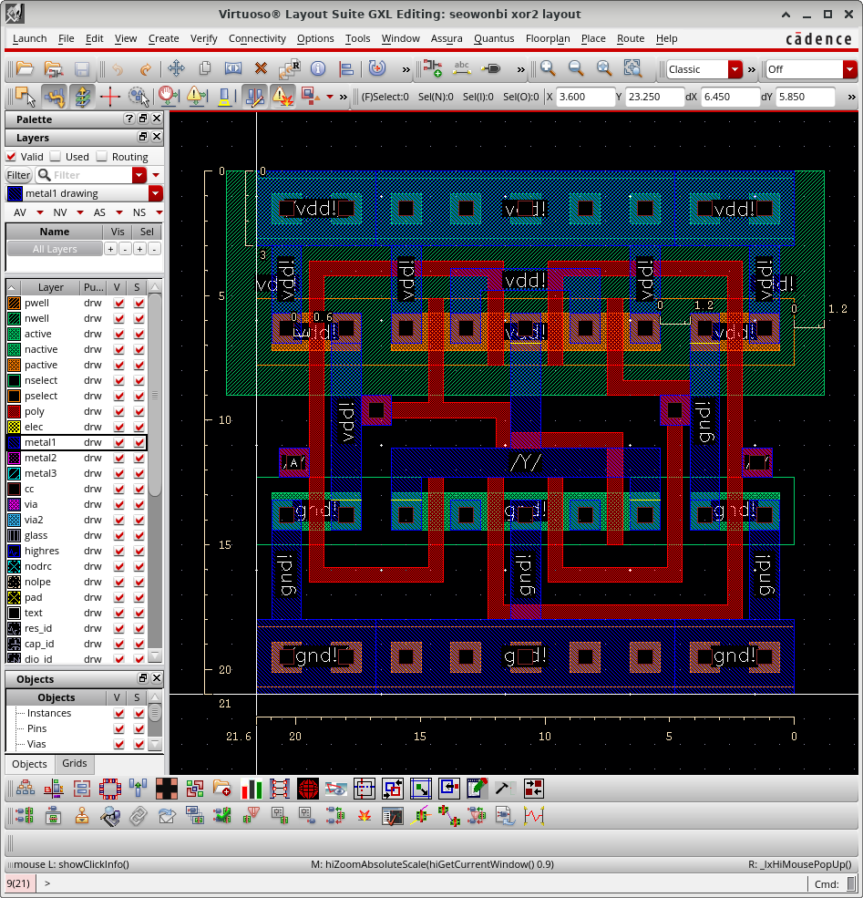

Problem 12 – XOR2 LVS
